**Check 4 things below:**

%% Check each subject

% 1.Hand trace across all trials (color shade)

% 2.Eye and hand trace of example trials

% 3.Reaction time across all trials

% 4.Hand and eye error across all trials

**Operation:**

1. Put the hand and eye data file into the specified path to read.



1. Run <**CheckPerSubj.m**>, then the figures will be saved in specified outputFolder path.



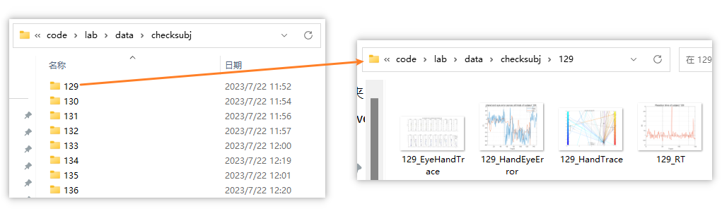

1. Make a pdf file for each subject and store

